For this Module 1.1 discussion, I selected topic #6 “People Scan the Screen based on the past experience and Expectation”, and #10 “Red and Blue Together are Hard on the Eyes”.
The reading underlines scanning the screen is based on the experience and expectation, but specifically, users often follow an “F-pattern” for text-heavy pages and a “Z-pattern” for image-heavy or landing pages. They scan headings, links, and the first few words of paragraphs. They do not read word for word because of reading fatigue, behavioral patterns, mental models, compulsive behavior, and addiction.
The visual example in web design: a well-designed webpage utilizing the Z-pattern to guide a user: Top left for
Logo; Top Right for Call to Action /Menu; Middle center for Main Hero Image or hook; bottom left for sub headline and bottom right for primary CTA Button.
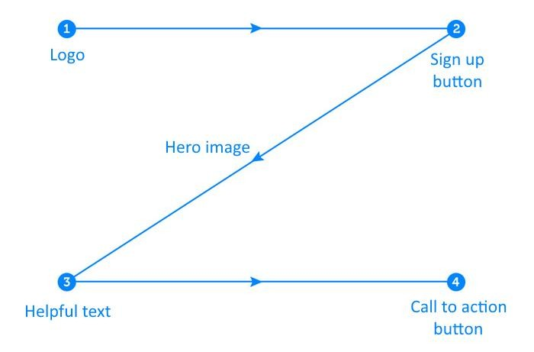

The phenomena of red and blue together create intense eye strain is scientifically known as chromostereopsis, where the visual cortex struggles to process the different depths of red and blue simultaneously. While the text mentions it is hard to read, it does not explicitly state that it causes actual physical fatigue or eyestrain. In web design this is particularly problematic for accessibility (Web Content Accessibility Guidelines (WCAG) standards), as it can trigger motion sickness or headaches for users with visual sensitivities.
The visual Example:
- Bad or poor: Bright red text on a bright blue background

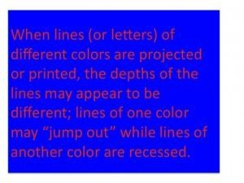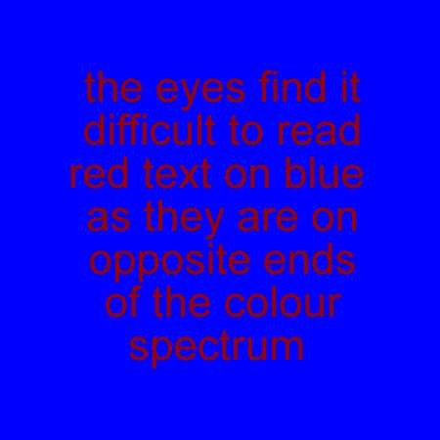

- Good: A muted, darker blue background with light gray or white text, or using red strictly as an accent color for call-to action button, not in a large block of text.
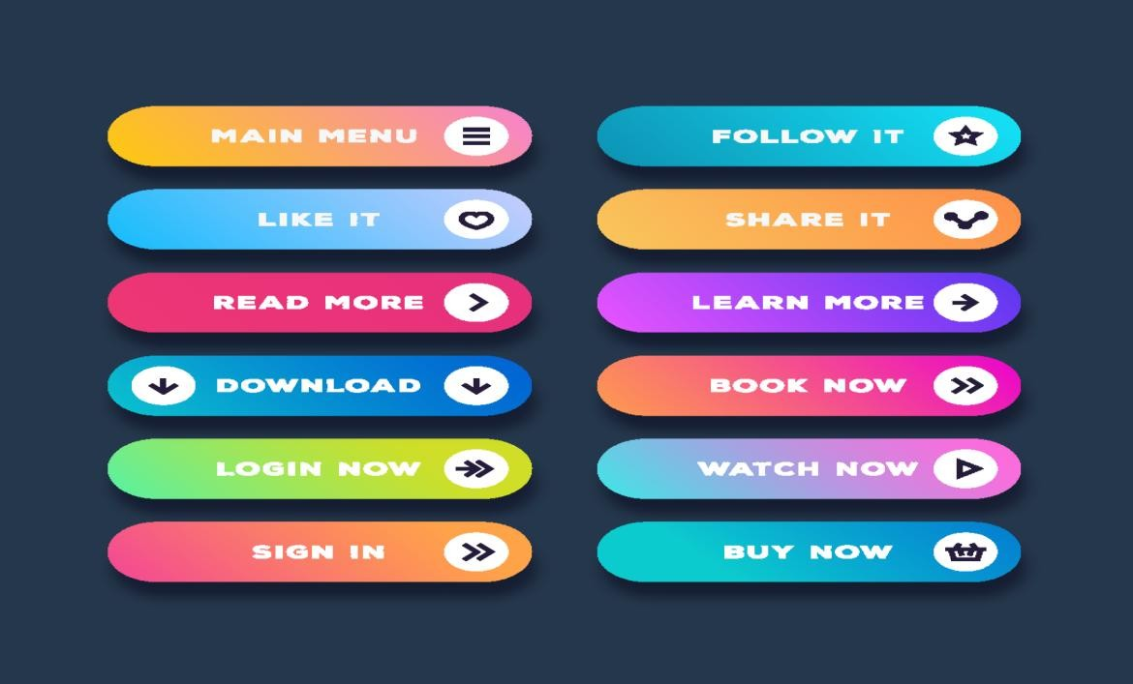

- Contrasting Background and Foreground colors is crucial in web Design. Even though there are online tools like CheckMyColors.com to test site’s colors and report on the contrast ratio between elements on the page, and ContrastChecker.com to test the choices a against the Web Content Accessibility Guidelines (WCAG), the bellow chart can help us to get better background and foreground combinations to avoid or reduce eyestrain(chromostereopsis)
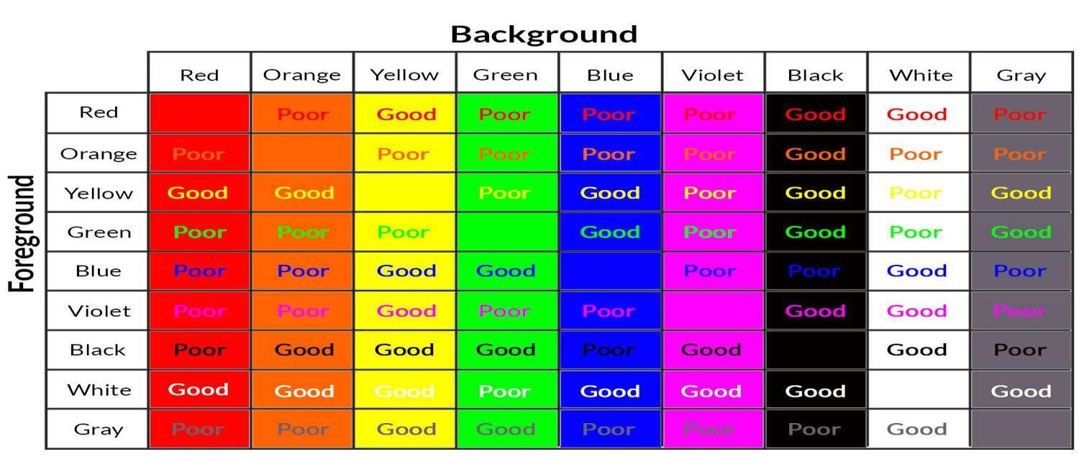

https://www.thoughtco.com/contrasting-foreground-background-colors-4061363 https://www.libautech.com/blog-posts-second/best-color-cta-button https://www.blog.theteamw.com/2009/11/09/100-things-you-should-know-about-people-
9-chromostereopsis-is-hard-on-the-eyes/ https://en.forum.elvenar.com/index.php?threads/version-1-67-crafting.8781/page-2

